DANISH RYWEN T
25MML0048

OBJECT DETECTION IN VIDEOS USING YOLOv8

Flow Diagram :
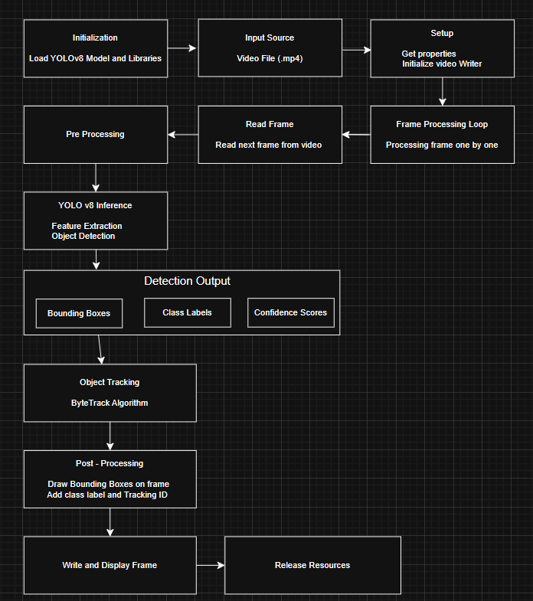
This project presents a pipeline for detecting and tracking objects in video streams using the YOLOv8 model. The system takes a video as input and processes it frame by frame using OpenCV. Each frame is analyzed by the YOLOv8 model to detect objects and generate bounding boxes, class labels, and confidence scores.
To maintain object identity across frames, a tracking algorithm such as ByteTrack is used, which assigns unique IDs to detected objects. The results are then visualized by drawing bounding boxes and labels on each frame and saved as an output video.

Code :
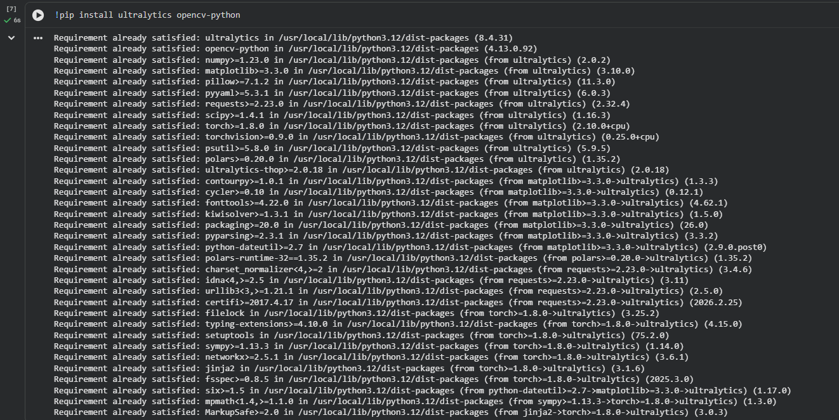
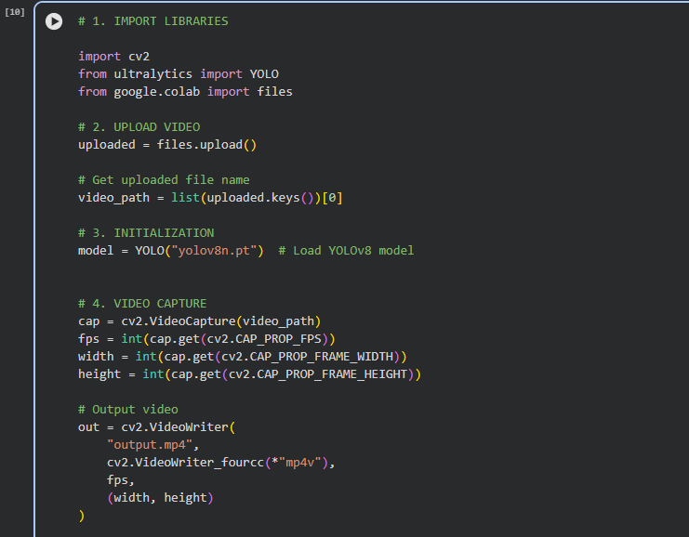
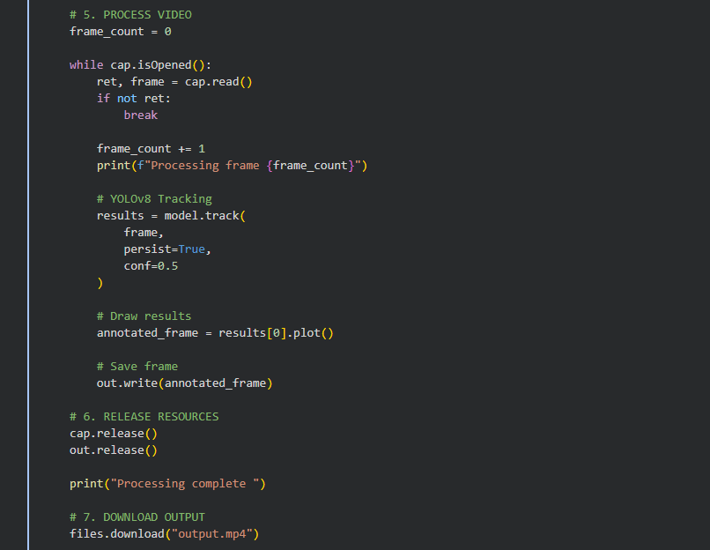

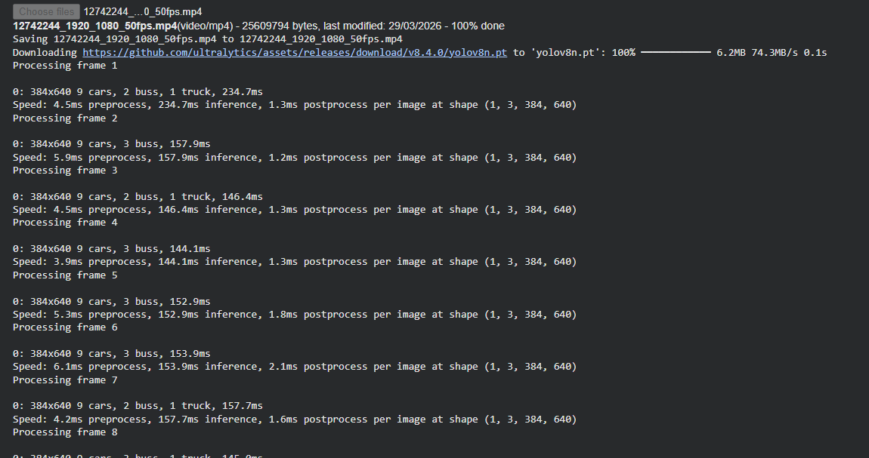

Output Video:
